Platelet-Lymphocyte Ratio in Predicting Mortality of Patients in Pediatric Intensive Care Unit
Abstract
Background: Pediatric intensive care units (PICU) have special equipment for treatment of children with life-threatening conditions Platelet-lymphocyte ratio (PLR) is a novel inflammatory marker. It has been shown that PLR can be used as a useful marker for early diagnosis and treatment of some diseases. This study aimed to research whether PLR is a predictive factor of mortality risk in PICU patients. Methods: This retrospective and prospective observational cohort study was conducted on 100 children hospitalized in the PICU in Benha University Hospitals. Patients were evaluated by different disease severity scores using sequential organ failure assessment (SOFA), pediatric index of mortality 2 score (PIM2), preserved ratio impaired spirometry (PRISM III) and pediatric logistic organ dysfunction (PELOD). Results: PLR, and NLR were significantly lower in non- survivors compared to survivors (P<0.05). PLR with AUC 0.975 can significantly predict survivors (P<0.001), at cutoff value of ≤4.97, with 93.55 % sensitivity, 91.30% specificity, 82.9% PPV and 96.9% NPV. NLR with AUC 0.821 can significantly predict survivors (P<0.001), at cutoff value of ≤0.20 with 77.42% sensitivity, 68.12% specificity, 52.2% PPV and 87.0% NPV. Conclusion: Hematological parameters and scores were used for predicting PICU mortality PLR and NLR are simple hematological biomarkers, easy to calculate, and cost-effective, and ratios are better than individual parameters.
Keywords: Platelet-Lymphocyte Ratio, Mortality, PICU.
Introduction
Pediatric intensive care units (PICU) have special equipment for treatment of children with life-threatening conditions (1). These patients’ conditions may be due to a severe illness, poisoning, trauma, or unpredictable complications arising from surgery (2). The main purpose of therapies in a PICU is supporting patients until the dysfunction heals by natural means or the toxic material or the infection is eliminated (3). Morbidity and mortality rates in patients admitted to the PICU are higher than in other pediatric patients, because of the worse clinical picture (4, 5). In PICU patients with a severe clinical course, there are several markers that can reveal the severity of inflammation, but they are expensive and difficult to work with (6).
Lymphocytes are immune cells, which play an important role in immune response. Platelets are a key factor affecting coagulation function and inflammatory response (7, 8). Actually, platelet-to-lymphocyte ratio (PLR) is considered a simple, inexpensive, widely available inflammatory indicator, independent risk factor and prognostic predictor for many critical cases (9). PLR is a novel inflammatory marker. It has been shown that PLR can be used as a useful marker for early diagnosis and treatment of some diseases (10). Also, it has been shown that PLR is a useful marker in predicting the prognosis of some diseases in adults (11).
In recent years, studies have reported that platelets and lymphocytes play critical roles in the inflammatory process (12). Therefore, the PLR has received research attention recently, as it may act as an indicator of inflammation in a wide spectrum of diseases, such as myocardial infarction, acute kidney injury (AKI), hepatocellular carcinoma and non-small cell lung cancer (13, 14).
Based on the findings of previous studies, it is reasonable to speculate the presence of a potential relationship between PLR and mortality of patients in pediatric intensive care unit. However, there is a lack in investigations that had been conducted. Therefore, this study aims to research whether PLR is a predictive factor of mortality risk in PICU patients.
The purpose of this study was to research whether PLR is a predictive factor of mortality risk in PICU patients.
Patients and methods
This retrospective and prospective observational cohort study was conducted on 100 children hospitalized in the PICU in Benha University Hospitals in the duration from to………
An informed written consent was obtained from the parents or guardian, they received an explanation of the purpose of the study and had a secret code number. The study was done after being approved by the Research Ethics Committee, Faculty of Medicine, Benha University.
Inclusion criteria were children aged between 1 month to 18 years, both sexes, and children who were hospitalized in the PICU with any disease except oncology.
Exclusion criteria were patients with incomplete intervention or medical records, and conditions that may affect the hematological parameters of patients (chemotherapy, immunosuppressive therapy and conditions, hematological malignancy, immunodeficiency).
Patients admitted to PICU with multi system affection were retrospectively registered in terms of: Demographical features: [name, age, sex, body mass index (BMI), cause of admission]. Complete history included: diagnosis, length of stay, the sequential organ failure assessment score (SOFA score), and platelet]. Complete examination for detection of any abnormalities: [Respiratory, circulatory, gastrointestinal and neurological dysfunction).
Blood sampling
A total of 2 mL of venous blood was collected from the peripheral accessible veins in an ethylenediamine tetra acetic acid (EDTA) vial within one hour of admission to the PICU. Complete blood indices were assessed by an automated hematology analyzer and ratios (PLR, PLT/MPV, and NLR) were subsequently calculated from the values obtained from the analyzer.
RBCs indices including RDW, hemoglobin, hematocrit, mean corpuscular volume (MCV), mean corpuscular hemoglobin (MCH) and mean corpuscular hemoglobin concentration (MCHC) and platelet indices including platelet count, platletcrit, mean platelet volume (MPV), platelet differential width (PDW) and large platelet cell ratio (L-PCR) were measured by automated hematology analyzer "Sysmex XS-800i (SN: 63387)" as one part of a complete blood cell count. Normal red cell distribution width coefficient variant (RDWCV) was defined as 11.5%-14.5% in the laboratory of our hospital while the normal range of PLT, MPV, PDW, PLCR, and PCT were 140 – 440 x 109 /L, 8–15 fl, 10– 17%, 13–43%, and 0.11–0.28% respectively. Serum CRP levels were examined with Quick Read CRP test kit (Orion Corporation, Orion Diagnostica, Espoo, Finland).
All patients had neutrophil, lymphocyte, and platelet counts results within the first hour of intensive care unit admission and within 24 hours before discharge. Both on the first day and on the day of discharge, PLR1 and PLR2 were calculated by the division of platelet count to the lymphocyte count. The complete blood parameters were examined at our university hospital biochemistry laboratory. Leucocyte, lymphocyte, neutrophil and platelet counts, and NLR, PLR values in complete blood count during intensive care unit stay and on the day of discharge.
All patients were evaluated by different disease severity scores using SOFA score: SOFA (15), pediatric index of mortality 2 score (PIM2), PRISM III (16) and pediatric logistic organ dysfunction (PELOD)(17).
Outcomes
Length of stay (LOS): referred to the duration of stay in days from the date of admission to the date of discharge, at the end of the PICU stay regarding survival.
Approval code:
Statistical analysis
Statistical analysis was done by SPSS v28 (IBM Inc., Armonk, NY, USA). Quantitative variables were presented as mean and standard deviation (SD) and compared between the two groups utilizing unpaired Student's t- test. Qualitative variables were presented as frequency and percentage (%) and were analyzed utilizing the Chi-square test or Fisher's exact test when appropriate. A two tailed P value < 0.05 was considered statistically significant. Evaluation of diagnostic performance was performed and presented as diagnostic sensitivity, specificity, positive predictive value (PPV) and negative Predictive value (NPV). Receiver operating characteristic curve (ROC-curve) analysis: The overall diagnostic performance of each test was assessed by ROC curve analysis. The area under the curve (AUC) evaluates the overall test performance (where the area under the curve >50% denotes acceptable performance and area about 100% is the best performance for the test)
Results
Our study included 100 patients; of them 69 (68%) were survivors and 31 (31%) were non-survivors. There was no significant difference between both groups regarding age, sex and residence, causes of admission including and vital signs. Table 1
Hb concentration, PLT count, PLR, NLR, phosphorus and Na and albumin were significantly lower in non- survivors compared to survivors (P<0.05). Lymphocytes, Monocytes, neutrophil, liver enzymes (ALT and AST), CRP and lactate were significantly higher in non- survivors compared to survivors (P<0.05), with no significant difference between both groups regrading WBCs count, K and Ca, Non-survivors had significantly lower pH and bicarbonate levels compared to survivors (P<0.001, <0.001). Table 2
SOFA score, PIM2 score, PRISM, PELOD were significantly higher in non survivors compared to survivors (P<0.05). The length of hospital stay was significantly prolonged in non survivors compared to survivors (P<0.001). Table 3
PLR with AUC 0.975 can significantly predict survivors (P<0.001), at cutoff value of ≤4.97, with 93.55 % sensitivity, 91.30% specificity, 82.9% PPV and 96.9% NPV. NLR with AUC 0.821 can significantly predict survivors (P<0.001), at cutoff value of ≤0.20 with 77.42% sensitivity, 68.12% specificity, 52.2% PPV and 87.0% NPV. SOFA score with AUC 0.987 can significantly predict survivors (P<0.001), at cutoff value of >6 with 100% sensitivity, 94.20% specificity, 88.6% PPV and 100% NPV. PIM2 score with AUC 0.850 can significantly predict survivors (P<0.001), at cutoff value of >5.3 with 87.10% sensitivity, 71.01% specificity, 57.4% PPV and 92.5% NPV. PRISM with AUC 0.889 can significantly predict survivors (P<0.001), at cutoff value of >6 with 80.65% sensitivity, 63.77% specificity, 51.9% PPV and 91.7% NPV. PELOD with AUC 0.987 can significantly predict survivors (P<0.001), at cutoff value of >5.3 with 100% sensitivity, 94.20% specificity, 88.6% PPV and 100% NPV. Figure 1
Discussion
In our study, 69 (68%) children were survivors, and 31 (31%) children were non-survivors. There was no significant difference between both groups regarding age, sex, and residence.
In agreement with our findings, Mahalingam et al. (18) reported that 156 (56.7%) children were survivors and 119 (43.3%) children were non-survivors during the study period. There was no significant difference between both groups regarding age and sex (p=0.19 and p=0.55 respectively).
In disagreement with our results, Wu et al. (19) reported that there was a significant difference between both groups regarding age and sex (p<0.001 and p=0.004 respectively). This could be explained by larger sample size and different research design.
In the present study, there was an insignificant difference between both groups regarding vital signs (pulse rate, RR, SBP, and DBP).
In agreement with our findings, Mahalingam et al. (18) showed that there was no significant difference between survivors (n=156) and non-survivors (n=119) groups regarding pulse rate, RR, and SBP (p=0.08, p=0.86 and p=0.64 respectively).
In contrast with us, Misirlioglu (20) reported that sepsis was significantly higher in survivors compared to non-survivors (p<0.001). Shock, multi-organ failure, and renal failure were significantly lower in survivors compared to non-survivors (p<0.001).
According to our study, Hb concentration and PLT count were significantly lower in non-survivors compared to survivors (P=0.006, <0.001). Lymphocytes, monocytes, and neutrophils were significantly higher in non-survivors compared to survivors (P<0.001, 0.024, <0.001), with no significant difference between both groups regarding WBC count. Platelet-lymphocyte ratio (PLR) and neutrophil-lymphocyte ratio (NLR) were significantly lower in non-survivors compared to survivors (P<0.001, 0.025).
In alignment with our findings, Tekin et al (21) reported that the NLR, and PLR values were significantly lower in non-survivors (n=13) than in survivors (n=345) (NLR, 6.2±5.7 versus 2.6±2.5, P<0.001; PLR, 145.3±85.0 versus 46.2±25.2, P<0.001). Hb concentration was significantly lower in non-survivors compared to survivors (P<0.001). Lymphocytes, monocytes, and neutrophils were significantly higher in non-survivors compared to survivors (p<0.05).
This result came in disagreement with Wu et al. (19) showed that NLR and PLR were significantly lower in survivors (n=18673) compared to non-survivors (n=3149) (p<0.001)). Lymphocytes and neutrophils were significantly lower in non-survivors (n=18673) compared to survivors (n=3149) (p<0.001)). This could be explained by larger sample size and different research design.
In the current study, with regard to the serum electrolytes, phosphorus and Na were significantly lower in non-survivors compared to survivors (P<0.001, <0.001), whereas K and Ca were insignificantly different between both groups. Concerning the other laboratory investigation, liver enzymes (ALT and AST), CRP, and lactate were significantly higher in non-survivors compared to survivors (P<0.05). Albumin was significantly lower in non-survivors compared to survivors (P<0.001). The non-survivor’s group had significantly lower pH and bicarbonate levels compared to the survivors (P<0.001, <0.001).
In alignment with our findings, Tekin et al (21) reported that the ALT, and AST values were significantly higher in non-survivors (n=13) than in survivors (n=345) (p<0.05).
Regarding the present study, SOFA score, PRISM, PELOD, and PIM2 score were significantly higher in non-survivors compared to survivors (P<0.001). The length of hospital stay was significantly prolonged in non-survivors compared to survivors (P<0.001).
These results were in agreement with Shenoy and Patil (22) who reported that PELOD-2 and PRISM III were significantly higher in non-survivors (n=48) compared to survivors (n=277) (P<0.001). However, the length of hospital stay was significantly prolonged in survivors compared to non-survivors (P<0.001).
In the current study, PLR with AUC 0.975 can significantly predict survivors (P<0.001), at a cutoff value of ≤4.97, with 93.55 % sensitivity, 91.30% specificity, 82.9% PPV, and 96.9% NPV. NLR with AUC 0.821 can significantly predict survivors (P<0.001), at a cutoff value of ≤0.20 with 77.42% sensitivity, 68.12% specificity, 52.2% PPV and 87.0% NPV.
In agreement with our findings, Mahalingam et al. (18) studied the sensitivity and specificity of PLR ≥ 3.9 and NLR ≥ 7 for the prediction of mortality in 275 children admitted to the PICU. They showed that PLR had a sensitivity of 85.71 %, specificity of 14.10%, PPV of 43.22%, and NPV of 56.41% for predicting mortality. NLR had a specificity of 92.31% and an NPV of 56.69% for predicting mortality.
In the present study, a SOFA score with AUC 0.987 can significantly predict survivors (P<0.001), at a cutoff value of >6 with 100% sensitivity, 94.20% specificity, 88.6% PPV, and 100% NPV. PIM2 score with AUC 0.850 can significantly predict survivors (P<0.001), at a cutoff value of >5.3 with 87.10% sensitivity, 71.01% specificity, 57.4% PPV and 92.5% NPV. PRISM with AUC 0.889 can significantly predict survivors (P<0.001), at a cutoff value of >6 with 80.65% sensitivity, 63.77% specificity, 51.9% PPV and 91.7% NPV. PELOD with AUC 0.987 can significantly predict survivors (P<0.001), at a cutoff value of >5.3 with 100% sensitivity, 94.20% specificity, 88.6% PPV and 100% NPV.
In agreement with us, Misirlioglu (20) studied the sensitivity and specificity of PELOD, PIM2, and PRISM in 670 PICU children. They reported that the PELOD cut-off value of ≥ 7 predicted increased mortality with a sensitivity of 100% and specificity of 96.1%. The PIM2 cut-off value of ≥ 90 predicted increased mortality with a sensitivity of 100% and specificity of 98.2%. The PRISM cut-off value of ≥ 12 predicted increased mortality with a sensitivity of 96% and specificity of 94.8%.
Moreover, Shimoyama et al. (23) studied the SOFA score for predicting mortality in 32 patients with GIP treated in the ICU. They reported that SOFA score with a cut-off value of ≥ 6 predicted increased mortality with a sensitivity of 75%, specificity of 87.5%, PPV of 666.7%, and NPV of 91.3%.
Conclusion
Hematological parameters and scores were used for predicting PICU mortality PLR and NLR are simple hematological biomarkers, easy to calculate, and cost-effective, and ratios are better than individual parameters. Our study showed that the PLR with AUC 0.975 can significantly predict survivors, at a cutoff value of ≤4.97, with 93.55 % sensitivity, 91.30% specificity, 82.9% PPV, and 96.9% NPV.
Sources of funding
This research did not receive any specific grant from funding agencies in the public, commercial, or not-for-profit sectors.
Author contribution
Authors contributed equally to the study.
Conflicts of interest
No conflicts of interest
References
1. Mahmoud RA, Abdelatif RG, Bakheet MAM, Mohamed MM. Predictors of Outcome in an Egyptian Pediatric Intensive Care Unit. Egypt J Hosp Med. 2023;90:58-69.
2. Seifu A, Eshetu O, Tafesse D, Hailu S. Admission pattern, treatment outcomes, and associated factors for children admitted to pediatric intensive care unit of Tikur Anbessa specialized hospital, 2021: a retrospective cross-sectional study. BMC Anesthesiol. 2022;22:13-26.
3. Willems J, Hermans E, Schelstraete P, Depuydt P, De Cock P. Optimizing the Use of Antibiotic Agents in the Pediatric Intensive Care Unit: A Narrative Review. Paediatr Drugs. 2021;23:39-53.
4. Hernandez-Garcia M, Girona-Alarcon M, Bobillo-Perez S, Urrea-Ayala M, Sole-Ribalta A, Balaguer M, et al. Ventilator-associated pneumonia is linked to a worse prognosis than community-acquired pneumonia in children. PLoS One. 2022;17:50-8.
5. Soydan E, Guzin Y, Topal S, Atakul G, Colak M, Seven P, et al. Clinical Features and Management of Status Epilepticus in the Pediatric Intensive Care Unit. Pediatr Emerg Care. 2023:5-19.
6. Dhanalakshmi K, Venkataraman A, Balasubramanian S, Madhusudan M, Amperayani S, Putilibai S, et al. Epidemiological and Clinical Profile of Pediatric Inflammatory Multisystem Syndrome - Temporally Associated with SARS-CoV-2 (PIMS-TS) in Indian Children. Indian Pediatr. 2020;57:1010-4.
7. Sonmez O, Sonmez M. Role of platelets in immune system and inflammation. Porto Biomed J. 2017;2:311-4.
8. Cognasse F, Duchez AC, Audoux E, Ebermeyer T, Arthaud CA, Prier A, et al. Platelets as Key Factors in Inflammation: Focus on CD40L/CD40. Front Immunol. 2022;13:82-100.
9. Simon P, Le Borgne P, Lefevbre F, Cipolat L, Remillon A, Dib C, et al. Platelet-to-Lymphocyte Ratio (PLR) Is Not a Predicting Marker of Severity but of Mortality in COVID-19 Patients Admitted to the Emergency Department: A Retrospective Multicenter Study. J Clin Med. 2022;11:9-20.
10. Gasparyan AY, Ayvazyan L, Mukanova U, Yessirkepov M, Kitas GD. The Platelet-to-Lymphocyte Ratio as an Inflammatory Marker in Rheumatic Diseases. Ann Lab Med. 2019;39:345-57.
11. Simadibrata DM, Pandhita BAW, Ananta ME, Tango T. Platelet-to-lymphocyte ratio, a novel biomarker to predict the severity of COVID-19 patients: A systematic review and meta-analysis. J Intensive Care. 2022;23:20-6.
12. Qu R, Ling Y, Zhang YH, Wei LY, Chen X, Li XM, et al. Platelet-to-lymphocyte ratio is associated with prognosis in patients with coronavirus disease-19. J Med Virol. 2020;92:1533-41.
13. Shen Y, Huang X, Zhang W. Platelet-to-lymphocyte ratio as a prognostic predictor of mortality for sepsis: interaction effect with disease severity-a retrospective study. BMJ Open. 2019;9:20-30.
14. Jiang H, Li D, Xu T, Chen Z, Shan Y, Zhao L, et al. Systemic Immune-Inflammation Index Predicts Contrast-Induced Acute Kidney Injury in Patients Undergoing Coronary Angiography: A Cross-Sectional Study. Front Med (Lausanne). 2022;9:84-90.
15. Lambden S, Laterre PF, Levy MM, Francois B. The SOFA score-development, utility and challenges of accurate assessment in clinical trials. Crit Care. 2019;23:374-88.
16. Mirza S, Malik L, Ahmed J, Malik F, Sadiq H, Ali S, et al. Accuracy of Pediatric Risk of Mortality (PRISM) III Score in Predicting Mortality Outcomes in a Pediatric Intensive Care Unit in Karachi. Cureus. 2020;12:89-99.
17. Dewi W, Christie CD, Wardhana A, Fadhilah R, Pardede SO. Pediatric Logistic Organ Dysfunction-2 (Pelod-2) score as a model for predicting mortality in pediatric burn injury. Ann Burns Fire Disasters. 2019;32:135-42.
18. Mahalingam S, Bhaskar V, Batra P, Dewan P, Gogoi P. Hematological Indices for Identifying Adverse Outcomes in Children Admitted to Pediatric ICUs. Cureus. 2024;16:44-60.
19. Wu X, Luo Q, Su Z, Li Y, Wang H, Liu Q, et al. Neutrophil-to-lymphocyte ratio as a predictor of mortality in intensive care unit patients: a retrospective analysis of the Medical Information Mart for Intensive Care III Database. BMJ open. 2021;11:548-55.
20. Misirlioglu M. Platelet-lymphocyte ratio in predicting mortality of patients in pediatric intensive care unit. J Clin Anal Med. 2018;9:488-92.
21. Tekin YK. Are neutrophil-to-lymphocyte and platelet-to-lymphocyte ratios associated with mortality in pediatric trauma patients? A retrospective study. Rambam Maimonides Med J. 2019;10:20-30.
22. Shenoy S, Patil S. Neutrophil Lymphocyte Ratio and Platelet Lymphocyte Ratio as Predictors of Disease Severity and Mortality in Critically Ill Children: A Retrospective Cohort Study. J Pediatr Intensive Care. 2023:30-40.
23. Shimoyama Y, Umegaki O, Agui T, Kadono N, Minami T. Neutrophil to lymphocyte ratio and platelet to lymphocyte ratio are superior to other inflammation-based prognostic scores in predicting the mortality of patients with gastrointestinal perforation. JA Clin Rep. 2017;3:49-55.

Table 1: Demographic data, causes of admission and vital signs of the studied groups
 |  |  | Total (n=100) | Survivors (n=69) | Non survivors  (n=31) | P value
Age (years) | Mean± SD |  | 8.1 ± 5 | 8.3 ± 5.08 | 7.7 ± 4.86 | 0.583
Age (years) | Range |  | 0.08 - 18 | 0.42 - 18 | 0.08 - 17 | 0.583
Sex | Male |  | 52 (52%) | 33 (47.83%) | 19 (61.29%) | 0.130
Sex | Female |  | 48 (48%) | 36 (52.17%) | 12 (38.71%) | 0.130
Residence | Urban |  | 48 (48%) | 33 (47.83%) | 15 (48.39%) | 0.956
Residence | Rural |  | 52 (52%) | 36 (52.17%) | 16 (51.61%) | 0.956
Congestive heart failure |  |  | 29 (29%) | 17 (24.64%) | 12 (38.71%) | 0.222
Multi-organ failure |  |  | 3 (3%) | 1 (1.45%) | 2 (6.45%) | 0.222
Pneumonia |  |  | 40 (40%) | 30 (43.48%) | 10 (32.26%) | 0.222
Sepsis |  |  | 28 (28%) | 21 (30.43%) | 7 (22.58%) | 0.222
Pulse rate (bpm) | Mean± SD | 137.7 ± 11.72 |  | 138.8 ± 11.52 | 135.3 ± 11.99 | 0.162
Pulse rate (bpm) | Range | 120 - 170 |  | 120 - 168 | 120 - 170 | 0.162
RR (breath/min) | Mean± SD | 32.6 ± 7.72 |  | 33.1 ± 7.92 | 31.5 ± 7.24 | 0.349
RR (breath/min) | Range | 20 - 45 |  | 20 - 45 | 20 - 45 | 0.349
SBP (mmHg) | Mean± SD | 129.9 ± 11.68 |  | 130.06±11.67 | 129.42±11.9 | 0.802
SBP (mmHg) | Range | 110 - 150 |  | 110-150 | 111-149 | 0.802
DBP (mmHg) | Mean± SD | 85.4 ± 8.09 |  | 85.14±8.43 | 86.1±7.37 | 0.589
DBP (mmHg) | Range | 70 - 100 |  | 70-100 | 72-98 | 0.589
RR: respiratory rate, SBP: systolic blood pressure, DBP: diastolic blood pressure.

Table 2: Laboratory investigations and arterial blood gas (ABG) of the studied groups
 |  | Total (n=100) | Survivors (n=69) | Non survivors (n=31) | P value
Hb (g/dL) | Mean± SD | 12.4 ± 0.89 | 12.54±0.89 | 12.02±0.81 | 0.006*
Hb (g/dL) | Range | 11 - 14 | 11-14 | 11-13.8 | 0.006*
WBCs  (*10⁹/L) | Mean± SD | 8.1 ± 1.4 | 8.24±1.37 | 7.85±1.45 | 0.200
WBCs  (*10⁹/L) | Range | 5.5 - 10.5 | 5.5-10.4 | 5.6-10.5 | 0.200
PLT (*10⁹/L) | Mean± SD | 198.9 ± 48.57 | 215.32 ± 42.27 | 162.26±41.57 | >0.001*
PLT (*10⁹/L) | Range | 100 - 298 | 154-298 | 100-230 | >0.001*
Lymphocytes (%) | Mean± SD | 38.1 ± 13.38 | 30.74±5.59 | 54.35±11.05 | >0.001*
Lymphocytes (%) | Range | 21 - 67 | 21-42 | 33-67 | >0.001*
Monocytes (%) | Mean± SD | 7.3 ± 1.68 | 7.04±1.53 | 7.86±1.88 | 0.024*
Monocytes (%) | Range | 4 - 11 | 4-9.2 | 4.2-11 | 0.024*
Neutrophil (%) | Mean± SD | 7.8 ± 1.3 | 7.2±0.88 | 9.25±0.91 | >0.001*
Neutrophil (%) | Range | 5.6 - 10.8 | 5.6-8.6 | 7.9-10.8 | >0.001*
PLR | Mean± SD | 5.96 ± 2.58 | 7.23±1.96 | 3.12±1.12 | >0.001*
PLR | Range | 1.61 - 13.41 | 3.93-13.41 | 1.61-6.76 | >0.001*
NLR | Mean± SD | 0.22 ± 0.06 | 0.24±0.05 | 0.18±0.05 | 0.025*
NLR | Range | 0.12 - 0.38 | 0.16-0.38 | 0.12-0.32 | 0.025*
Phosphorus (mg/dl) | Mean± SD | 4.1 ± 1.02 | 4.62±0.74 | 2.96±0.46 | >0.001*
Phosphorus (mg/dl) | Range | 2.1 - 5.8 | 3.5-5.8 | 2.1-3.7 | >0.001*
Na ⁺ (mEq/L) | Mean± SD | 136.8 ± 3.13 | 138.68 ± 1.14 | 132.65±1.82 | >0.001*
Na ⁺ (mEq/L) | Range | 130 - 140 | 137_140 | 130-135 | >0.001*
K⁺ (mEq/L) | Mean± SD | 4.3 ± 0.45 | 4.34±0.45 | 4.3±0.47 | 0.714
K⁺ (mEq/L) | Range | 3.5 - 5.1 | 3.5_5.1 | 3.5-5 | 0.714
Ca⁺² (mg/dL) | Mean± SD | 9 ± 0.89 | 9±0.92 | 8.97±0.83 | 0.888
Ca⁺² (mg/dL) | Range | 7.5 - 10.5 | 7.5-10.5 | 7.7-10.2 | 0.888
ALT (IU/L) | Mean± SD | 57.1 ± 41.02 | 30.84±7.89 | 115.42±17.61 | >0.001*
ALT (IU/L) | Range | 18 - 140 | 18-60 | 83-140 | >0.001*
AST (IU/L) | Mean± SD | 51.8 ± 40.77 | 31.25±6.77 | 97.55±47.4 | >0.001*
AST (IU/L) | Range | 20 - 230 | 20-50 | 42-230 | >0.001*
Albumin (g/dl) | Mean± SD | 3.7 ± 0.34 | 3.84±0.27 | 3.5±0.36 | >0.001*
Albumin (g/dl) | Range | 3 - 4.5 | 3.4-4.5 | 3-4 | >0.001*
CRP (mg/dl) | Mean± SD | 88.8± 51.04 | 61.73±18.57 | 148.98±48.86 | >0.001*
CRP (mg/dl) | Range | 31.2 - 235.8 | 31.2-100.2 | 57.8-235.8 | >0.001*
Lactate  (mmol/L) | Mean± SD | 2.1 ± 0.73 | 1.64±0.25 | 2.97±0.59 | >0.001*
Lactate  (mmol/L) | Range | 1.3 - 4.1 | 1.3-2 | 2.2-4.1 | >0.001*
PH | Mean± SD | 7.3 ± 0.09 | 7.37±0.01 | 7.18±0.05 | >0.001*
PH | Range | 7.1 - 7.39 | 7.35-7.39 | 7.1-7.25 | >0.001*
Bicarbonate  (mEq/L) | Mean± SD | 22.1 ± 3.16 | 23.57±2.36 | 18.87±2.14 | >0.001*
Bicarbonate  (mEq/L) | Range | 15 - 27 | 20-27 | 15-22 | >0.001*
Hb: haemoglobin, PLT: platelet count, WBCs: white blood cells, *: statistically significant as p value <0.05, PLR: platelet-lymphocyte ratio, NLR: Neutrophil-lymphocyte ratio,

Table 3: Clinical scores and length of hospital stay of the studied groups
 |  | Total (n=100) | Survivors (n=69) |  | Non survivors (n=31) | P value
SOFA score | Mean± SD | 5.3 ± 3.41 | 3.26±1.58 |  | 9.71±1.77 | >0.001*
SOFA score | Range | 1 - 12 | 1-10 |  | 7-12 | >0.001*
PIM2 score | Mean± SD | 10.9 ± 12.21 |  | 6.71±9.55 | 20.3±12.39 | >0.001*
PIM2 score | Range | 3.5 - 68 |  | 3.5_68 | 4.1_45.8 | >0.001*
PIM2 score | Median (IQR) | 5.15 (4.375 - 11.05) |  | 4.7 (4.2 - 5.4) | 20.9 (9.65 - 31.8) | >0.001*
PRISM | Mean± SD | 7.6 ± 4.15 |  | 5.7±2.4 | 11.94±4.01 | >0.001*
PRISM | Range | 1 - 17 |  | 1_13 | 4_17 | >0.001*
PELOD Score | Mean± SD | 4.8 ± 1.65 |  | 3.93±0.97 | 6.84±0.89 | >0.001*
PELOD Score | Range | 2.1 - 8.3 |  | 2.1-7.4 | 5.4-8.3 | >0.001*
Length of hospital stay (days) | Mean± SD | 7.8 ± 4.4 |  | 5.86±2.6 | 12.13±4.53 | >0.001*
Length of hospital stay (days) | Range | 1 - 20 |  | 1-13 | 4-20 | >0.001*
SOFA: sequential organ failure assessment, PIM2: paediatric index of mortality 2, PELOD: pediatric logistic organ dysfunction, PRISM: Preserved Ratio Impaired Spirometry *: statistically significant as p value <0.05,
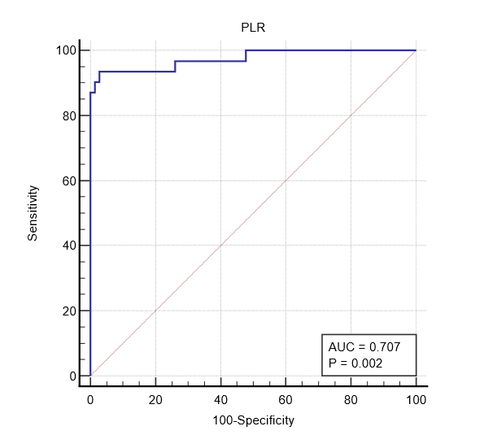 | 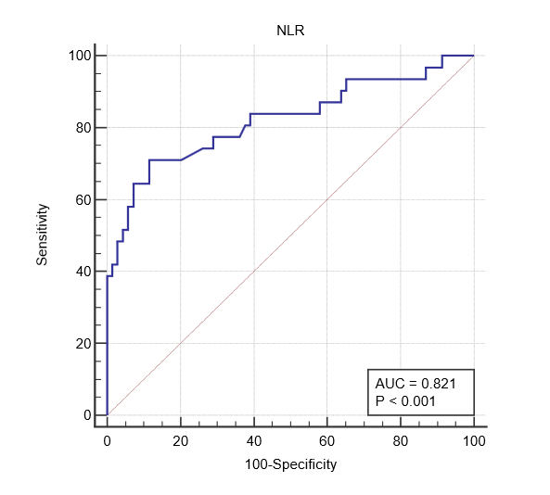
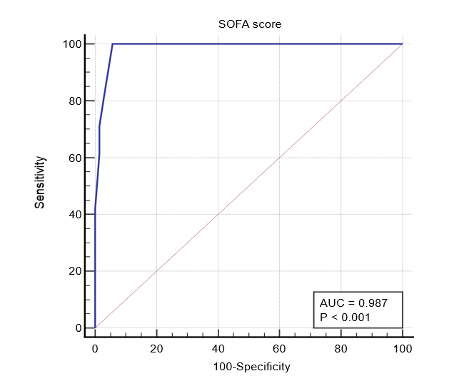 | 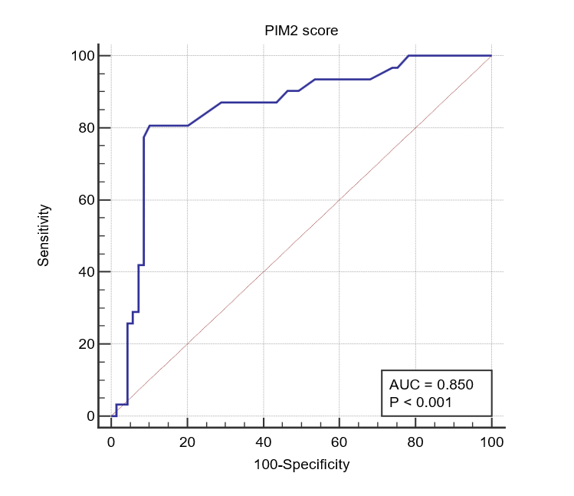
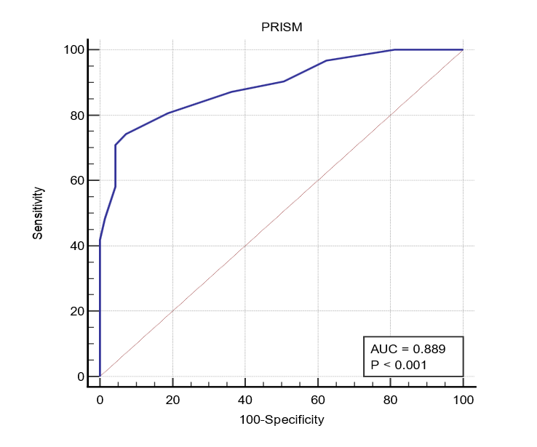 | 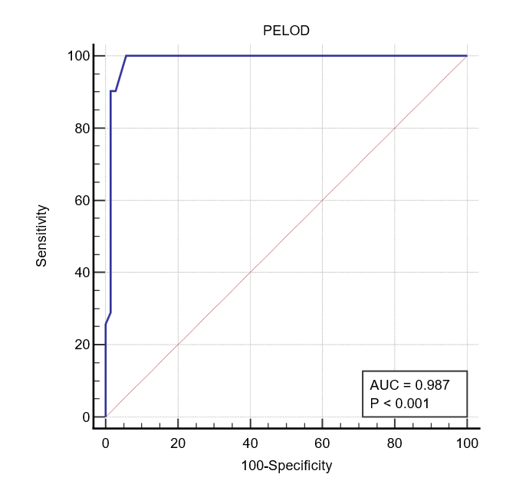
Figure 1: ROC curve analysis for predcition of survivor

